**Integration**

**Topics Covered**

• Getting familiar with the Qඝඉඖඛඍක® QUBE-Servo 2 Rotary Servo Experiment hardware.

• Using LඉඊVIEW™ to interact with QUBE-Servo 2 system.

• Sensor calibration.

**Prerequisites**

• The QUBE-Servo 2 has been setup and tested. See the QUBE-Servo 2 Quick Start Guide for details.

• Inertia disk load is on the QUBE-Servo 2.

• You have the QUBE-Servo 2 User Manual. It will be required for some of the exercises.

• You are familiar with the basics of LඉඊVIEW™ .

**1 Background**

**1.1 Using LabVIEW™**

LඉඊVIEW™ is used to interact with the hardware of the QUBE-Servo 2 system using a National Instruments myRIO

device. LඉඊVIEW™ is used to drive the DC motor and read angular position of the disk.

**1.2 DC Motor**

Direct-current motors are used in a variety of applications. As discussed in the QUBE-Servo 2 User Manual, the QUBE-Servo 2 has a brushed DC motor that is connected to a PWM amplifier. See the QUBE-Servo 2 User Manual for details.

**1.3 Encoders**

Similar to rotary potentiometers, encoders can also be used to measure angular position. There are many types of encoders but one of the most common is the rotary incremental optical encoder, shown in Figure 1.1. Unlike potentiometers, encoders are relative. The angle they measure depends on the last position and when it was last powered. It should be noted, however, that absolute encoders are available.

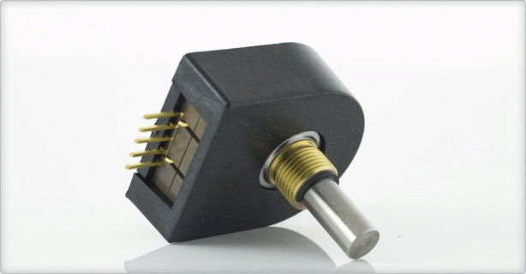

Figure 1.1: US Digital incremental rotary optical shaft encoder

The encoder has a coded disc that is marked with a radial pattern. This disc is connected to the shaft of the DC motor. As the shaft rotates, a light from a LED shines through the pattern and is picked up by a photo sensor. This effectively generates the A and B signals shown in Figure 1.2. An index pulse is triggered once for every full rotation of the disc, which can be used for calibration or homing a system.

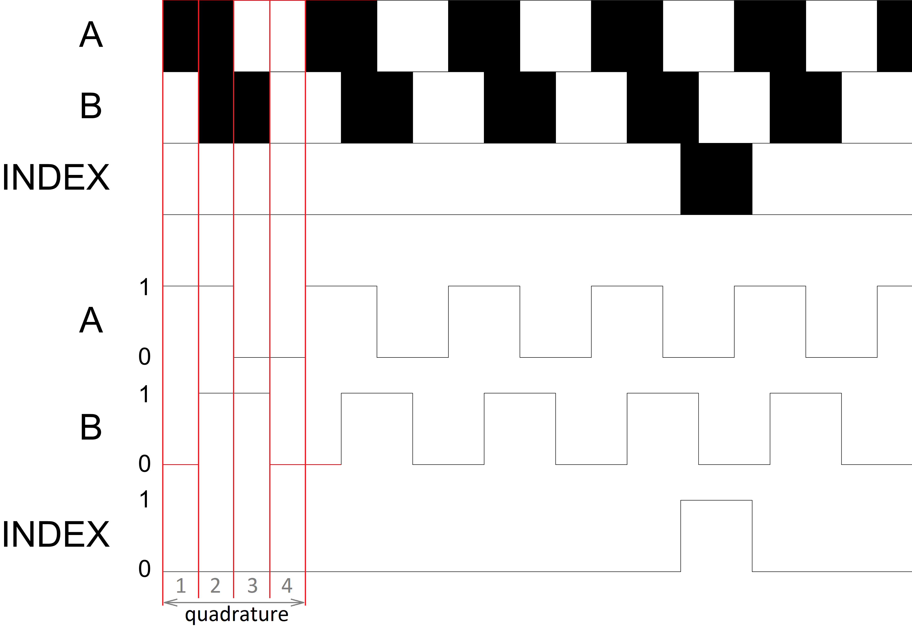

Figure 1.2: Optical incremental encoder signals

The A and B signals that are generated as the shaft rotates are used in a decoder algorithm to generate a count. The resolution of the encoder depends on the coding of the disc and the decoder. For example, a single encoder with 512 lines on the disc can generate a total of 512 counts for every rotation of the encoder shaft. However, in a quadrature decoder as depicted in Figure 1.2, the number of counts (and thus its resolution) quadruples for the same line patterns and generates 2048 counts per revolution. This can be explained by the offset between the A and B patterns: Instead of a single strip being either on or off, now there is two strips that can go through a variety of on/off states before the cycle repeats. This offset also allows the encoder to detect the directionality of the rotation, as the sequence of on/off states differs for a clockwise and counter-clockwise rotation.

**2 In-Lab Exercises**

In this lab, we will make a LඉඊVIEW™ Virtual Instrument (VI) to drive the DC motor and then measure it’s corresponding angle, as shown in Figure 2.1.

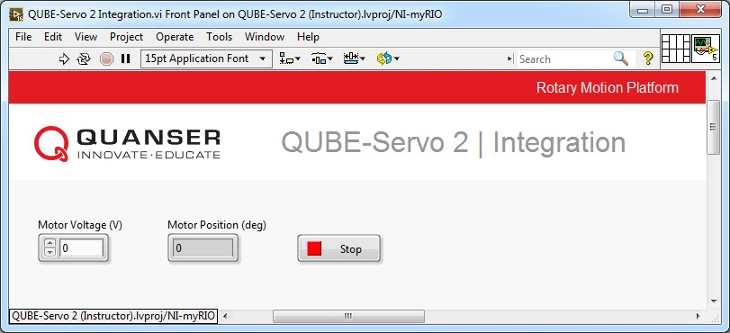

(a) Front panel

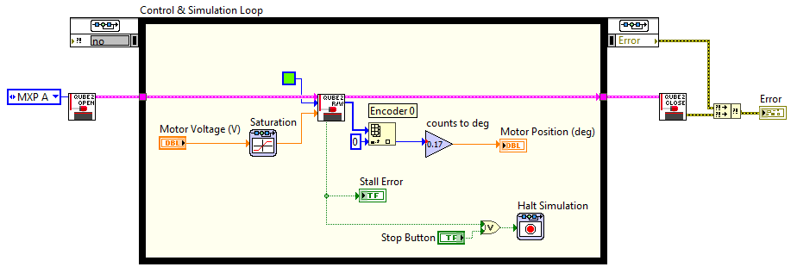

(b) Block diagram

Figure 2.1: VI used to drive motor and read angle on QUBE-Servo 2

**2.1 Conﬁguring a LabVIEW™ VI for the**

**QUBE-Servo 2**

Follow these steps build a LඉඊVIEW™ VI that will interface to the QUBE-Servo 2:

1. Load the LඉඊVIEW™ software.

2. Open QUBE-Servo 2.lvproj.

3. Start by using the QUBE-Servo 2 template VI. As shown in Figure 2.2, to open the template from the project, expand the NI myRIO target and click *Labs* | *1_Integration*, and open QUBE-Servo 2 Template.vi

4. In the block diagram, double-click on the Simulation Loop input node (or right-click on the border and select

*Configure Simulation Parameters*) to access the *Simulation Parameters...* box shown in Figure 2.3.

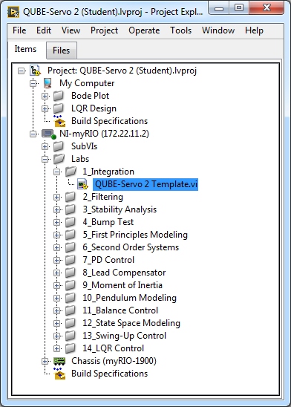

Figure 2.2: SRV02 LabVIEW project.

5. As shown in Figure 2.3, in the *Simulation Parameters* confirm the following settings:

• Final time (s): Inf

• ODE Solver: Runge-Kutta 1 (Euler)

• Step Size (s): 0.002

This configures the simulation to run until it is stopped by the user at a sampling rate of 500Hz. When performing control, any of the fixed solvers can be used but Runge-Kutta 1 is typically the default.

6. As shown in Figure 2.3, in the *Timing Parameters* confirm the following settings:

• Select *Synchronize Loop to Timing Source*

• Timing Source: 1 kHz Clock

• Select *Auto Period*

This synchronizes the simulation to the PC clock. Otherwise, the simulation would run as fast as possible

(which is fine when doing pure simulation, but generally not desired when interfacing to hardware).

7. Click on the OK button to apply the changes.

8. Run the VI by clicking on the *Run* button, which is the white arrow in the top-left corner. The *Status* LED strip on the QUBE-Servo 2 will switch from red to green.

9. If you successfully ran the VI without any errors, then you can stop the code by clicking on the Stop Button in the Front Panel Window. As shown in Figure 2.1, the Stop Button is wired to the Control & Simulation Loop stop condition in the block diagram.

**Note:** Avoid using the Abort Execution button in the VI toolbar. Using the Abort Execution button stops the VI before it completes execution, which could lead to unwanted behavior such as leaving external hardware in an unknown state. Therefore, it is good practice to enclose code that uses external resources in a loop with a Stop button.

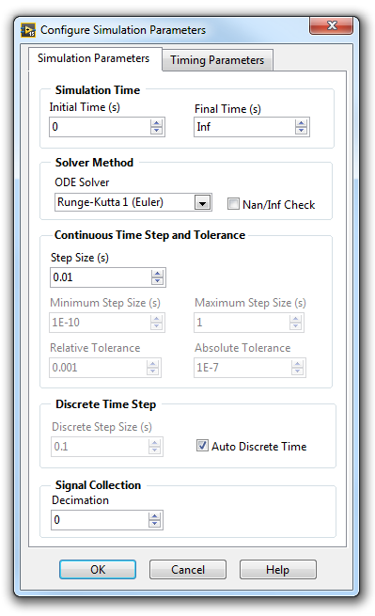

(a) Simulation Parameters (b) Timing Parameters

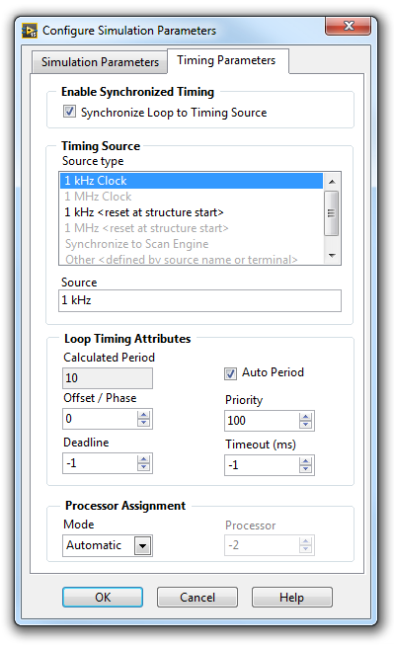

Figure 2.3: Simulation Loop Parameters Dialog

**2.2 Reading the Encoder**

Follow these steps to read the encoder:

1. As shown in Figure 2.1, connect the Encoder (counts) terminal of the QUBE 2 R/W block to a Index Array, Gain, and Numeric Indicator blocks. To read the output of *Encoder 0*, set the *index* terminal of the Index Array block to 0.

• You can find the Index Array block in the *Programming* | *Array* palette.

• You can find the Gain block in the *Control & Simulation* | *Simulation* | *Signal Arithmetic* palette.

• The indicator can be added by right-clicking on the Gain output and going to *Create* | *Indicator*.

2. Go to the front panel. You should see the Numeric Indicator.

3. Run the VI.

4. Rotate the disk back and forth. The Numeric Indicator shows the number of counts measured by the encoder.

The encoder counts are proportional to the angle of disk.

5. What happens to the encoder reading every time the VI is started? Stop the VI, move the disk around and re-start VI. What do you notice about the encoder measurement when the VI is re-started?

6. Measure how many counts the encoder outputs for a full rotation. Briefly explain your procedure to determine this and validate that this matches the specifications given in the QUBE-Servo 2 User Manual.

7. Ultimately we want to display the disk angle in degrees, not counts. Set the Gain block to a value that converts counts to degrees. This is called the *sensor gain*. Run the VI and confirm that the numeric indicator shows the angle of the disk correctly.

**2.3 Driving the DC Motor**

1. From the *Control & Simulation* | *Simulation* | *Nonlinear Systems* palette, add a Saturation block and wire it to the *Motor Voltage* terminal of the QUBE 2 R/W block. Double-click the Saturation block and configure it as follows:

• Upper limit: +10

• Lower limit: -10

**Note:** The Saturation block prevents over-voltage by limiting the voltage that is applied to the motor.

2. Add a Numeric Control by right-clicking on *input* terminal of the Saturation block and clicking *Create* | *Control*.

**Note:** The QUBE-Servo 2 incorporates a hardware stall detection which monitors the applied voltage and angular velocity of the DC motor to ensure that it does not stall. If the motor is motionless for more than 5 s with an applied voltage of over *±*5 V, current to the motor is cut. When a stall is detected, the *Stall Error* terminal of the QUBE 2 R/W block returns a true value. As shown in Figure 2.1, the *Stall Error* terminal is wired to the Halt Simulation. Whenever a stall is detected or the the Stop Button is pressed, the simulation loop stops executing.

3. Run the VI.

4. Set the Motor Voltage (V) block to 0*.*5. This applies 0*.*5 V to the DC motor in the QUBE-Servo 2. Confirm that you are obtaining a *positive measurement when a positive signal is applied*. This convention is important, especially in control systems when the design assumes the measurement goes up positively when a positive input is applied. Finally, in what direction does the disk rotate (clockwise or counter-clockwise) when a positive input is applied?

5. Click on the Stop button to stop the VI.

© 2017 Quanser Inc., All rights reserved.

Quanser Inc.

119 Spy Court

Markham, Ontario

L3R 5H6

Canada

[info@quanser.com](mailto:info@quanser.com)

Phone: 1-905-940-3575

Fax: 1-905-940-3576

Printed in Markham, Ontario.

For more information on the solutions Quanser Inc. offers, please visit the web site at:

[http://www.quanser.com](http://www.quanser.com/)

This document and the software described in it are provided subject to a license agreement. Neither the software nor this document may be used or copied except as specified under the terms of that license agreement. Quanser Inc. grants the following rights: a) The right to reproduce the work, to incorporate the work into one or more collections, and to reproduce the work as incorporated in the collections, b) to create and reproduce adaptations provided reasonable steps are taken to clearly identify the changes that were made to the original work, c) to distribute and publically perform the work including as incorporated in collections, and d) to distribute and publicly perform adaptations. The above rights may be exercised in all media and formats whether now known or hereafter devised. These rights are granted subject to and limited by the following restrictions: a) You may not exercise any of the rights granted to You in above in any manner that is primarily intended for or directed toward commercial advantage or private monetary compensation, and b) You must keep intact all copyright notices for the Work and provide the name Quanser Inc. for attribution. These restrictions may not be waved without express prior written permission of Quanser Inc.